Section 0 — Project Overview
This project set out to answer a question: can we predict which companies are likely to experience significant financial distress before it becomes obvious in their financial statements or public disclosures? The practical motivation is straightforward — an investor who identifies distress risk six to twelve months early can reduce exposure, initiate short positions, or at minimum avoid adding to a deteriorating name. By the time distress is obvious in the news, the opportunity is gone.
To answer this, we built a forward-looking corporate distress prediction model that combines market-based signals with balance sheet ratios, estimating the probability of financial deterioration over a 12-month horizon. The model covers 18 companies split evenly between distressed and stable firms, and all features were constructed using data available strictly before the evaluation date of March 18, 2025, with the distress label reflecting outcomes after that date. This time alignment was deliberate and non-trivial — it eliminates look-ahead bias, a common failure mode in financial ML models that makes backtests look better than they are in practice.
The output of the model is a ranked distress probability score for each company, segmented into four risk tiers — Critical (>80%), High (60-80%), Moderate (40-60%), and Low (<40%). These tiers are designed to translate directly into portfolio action: Critical companies are candidates for short positions or immediate exit, High tier companies warrant close monitoring, and Moderate tier companies are placed on a watchlist for reassessment within 30 days. This is not a purely academic exercise in fitting curves to data. Every design choice reflects what would matter in a real deployment.
Price data for 18 companies (2014–March 2025) was sourced via yfinance; NKLA was dropped for insufficient balance sheet coverage, leaving a perfectly balanced 9 distressed / 9 stable sample. Eight features were engineered: four market signals (return_12m, return_6m, volatility_6m, volume_change_1m) and four balance sheet ratios (total_liabilities_to_total_assets, interest_coverage, net_income_to_total_assets, current_ratio). Missing interest_coverage values (AAPL, BBBY, HD, MCD) were imputed to the within-fold median inside the sklearn Pipeline — never on the full dataset — to prevent leakage. return_12m is the strongest individual signal.

Section 1 — Key Data Insights (EDA)
The dataset shows clear separation between distressed and stable firms across both market-based and financial variables. Distressed companies exhibit strongly negative returns (around –67% on average), negative interest coverage, and negative ROA, while stable firms show positive returns (around +17%) and strong financial metrics.
Market-based signals, particularly returns and volatility, provide the strongest indication of distress, with declining prices often accompanied by elevated uncertainty. Interest coverage is also highly reliable, as negative values consistently align with distressed firms. Leverage is informative but context-dependent, and the current ratio is less reliable in isolation due to distortions from equity raises.
Outliers reinforce these patterns. Beyond Meat combines high liquidity with weak fundamentals, Workhorse shows extreme negative performance across key metrics, and Microsoft represents an unusually strong stable firm, contributing to the clear separation observed.

Section 2 — ML Results & Model Interpretation
Three models were trained using sklearn Pipelines:
- Logistic Regression
- Random Forest
- Gradient Boosting
All preprocessing (imputation + scaling) was applied within each fold using 3-fold stratified cross-validation.

Model | AUC | F1 | Precision | Recall
Logistic Regression | 1.000 ± 0.000 | 1.000 ± 0.000 | 1.000 ± 0.000 | 1.000 ± 0.000
Random Forest | 1.000 ± 0.000 | 1.000 ± 0.000 | 1.000 ± 0.000 | 1.000 ± 0.000
Gradient Boosting | 1.000 ± 0.000 | 1.000 ± 0.000 | 1.000 ± 0.000 | 1.000 ± 0.000

All three models achieved identical results, with AUC, F1, precision, and recall equal to 1.00 across all folds. This reflects complete separation between distressed and stable firms, driven by strong differences in returns and interest coverage. However, given the small sample size (n=18), these results likely overstate real-world performance.

Hyperparameter tuning of the random forest model produced identical performance across all configurations, indicating that results are driven by data separability rather than model complexity. The simplest specification was therefore selected.

With all models performing equally well, random forest was chosen for its interpretability and ability to capture non-linear relationships. The strong performance of logistic regression further suggests that the two groups are linearly separable in the feature space.

Predicted probabilities show full separation: all distressed firms fall into the highest risk tier, while all stable firms are classified as low risk. Home Depot has the highest probability among stable firms, likely reflecting weaker short-term returns and relatively higher leverage, and would be flagged for review in practice.

Feature importance was estimated using permutation-based methods (a proxy for SHAP-style interpretation). Volatility emerges as the most consistent predictor of distress, followed by 12-month and 6-month returns. Return on assets is the most informative financial ratio, while leverage, liquidity, and volume contribute less consistently. Volatility ranks highest because it is uniformly elevated across distressed firms, whereas returns vary in magnitude.

Section 3 — Limitiations & Next Steps

The primary limitation of this analysis is the small and deliberately constructed dataset. With only 18 companies, performance metrics are highly sensitive and likely optimistic, particularly given the clear separation between distressed and stable firms. This introduces selection bias, as real-world cases are typically more ambiguous and would likely result in lower model performance. The analysis is also cross-sectional, meaning it does not capture how firms evolve over time, and therefore cannot distinguish between gradual deterioration and short-term shocks. In addition, balance sheet data is drawn from annual filings, which may be outdated relative to the measurement date, potentially understating risk for rapidly deteriorating firms. The distress labels themselves are based on a multi-criteria definition and therefore involve some subjectivity, and the model’s probability outputs should be interpreted as relative risk indicators rather than definitive predictions.

To improve reliability, future work should focus on expanding the dataset across more companies, sectors, and time periods, allowing for more robust out-of-sample validation. Incorporating a time-series structure would enable the model to detect trends in financial deterioration rather than relying on a single snapshot. The feature set could also be extended to include alternative data, such as textual sentiment or options market signals, which may capture early warnings not reflected in financial statements. From a modelling perspective, survival analysis frameworks could provide more actionable outputs by estimating the timing of distress rather than just its likelihood. Finally, a production implementation would require automated data pipelines, regular retraining, and monitoring systems to ensure the model remains accurate as market conditions evolve.

Section 4 — Dashboard & Application

To translate model outputs into a usable decision-making tool, an interactive dashboard was developed to allow users to explore distress predictions at both the portfolio and company level. The dashboard presents a summary of key metrics, including the number of companies in each risk tier and overall model performance, providing a quick snapshot of the risk distribution across the sample.

At its core is a company risk screener, which allows users to filter firms by risk tier and minimum probability threshold. Results update dynamically, enabling rapid identification of high-risk companies. This functionality is designed to replicate a real investment workflow, where analysts screen a large universe and focus attention on the most critical names. The distress probability chart further reinforces this by visually separating distressed and stable firms, making the model’s classification intuitive and immediately interpretable.
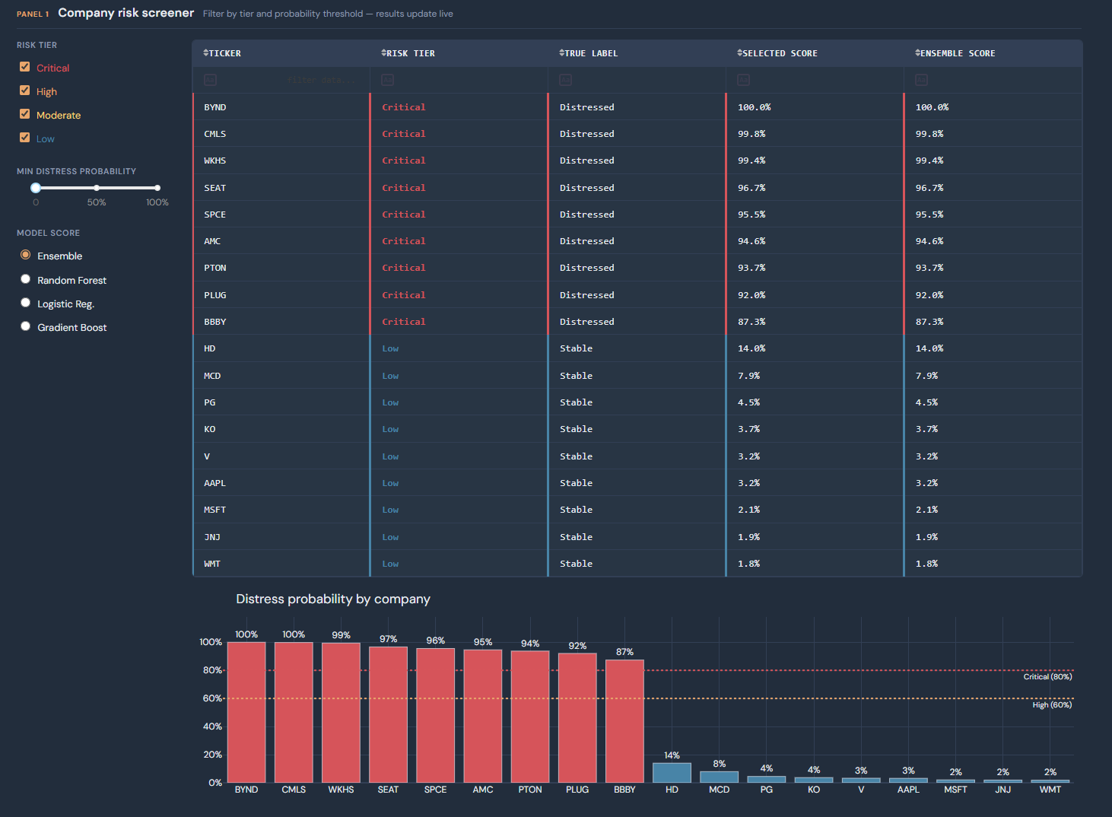
Figure 1: Company Risk Screener

The dashboard also includes a model performance panel, displaying cross-validation metrics, ROC curves, and confusion matrices. While the model achieves perfect in-sample performance, presenting these diagnostics allows users to assess model reliability and understand its limitations rather than treating predictions as a black box.

To provide interpretability, a feature importance and SHAP-style analysis panel highlights the drivers of distress predictions. Users can explore both global feature importance and firm-specific contributions, showing how variables such as volatility and returns influence individual predictions. This is particularly valuable in a financial context, where understanding why a firm is flagged is as important as the prediction itself.
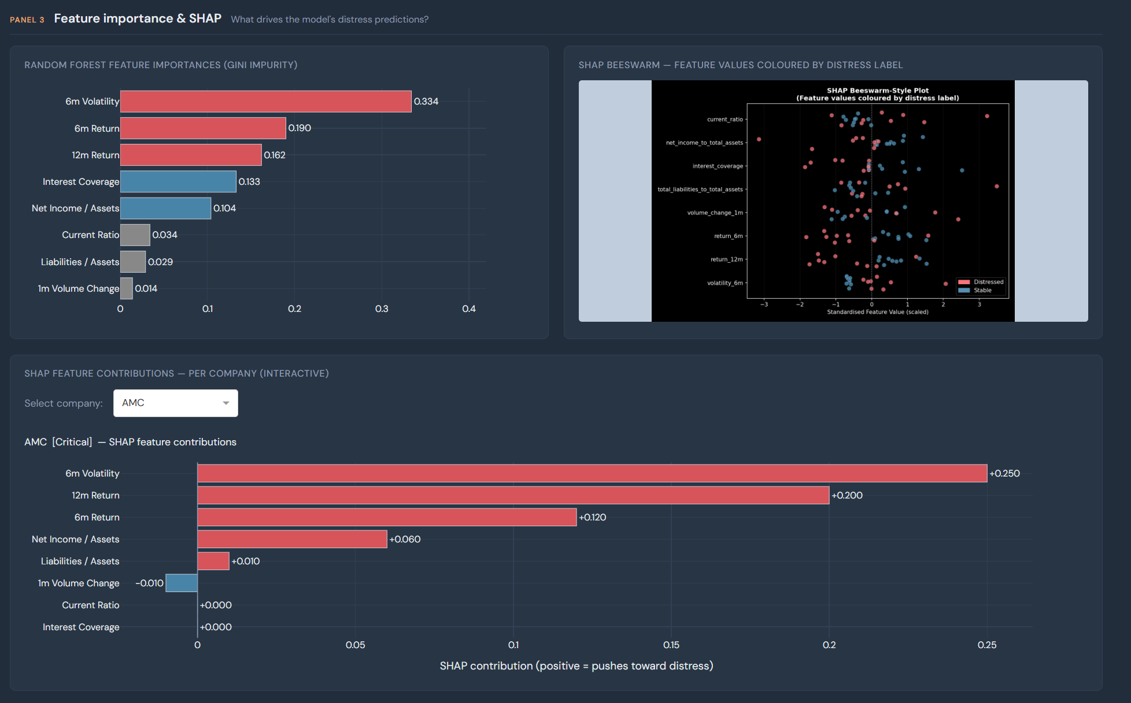
Figure 2: Feature Importance & SHAP

Finally, the company deep-dive view allows users to inspect individual firms in detail, combining feature profiles with model outputs across all classifiers. This enables a more granular assessment of risk and supports informed decision-making rather than relying solely on a single probability score.
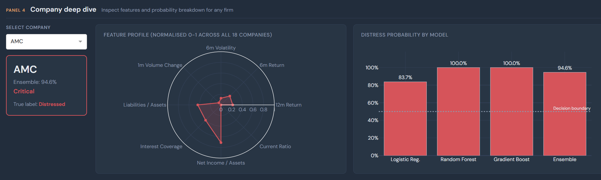
Figure 3: Company Deep Dive

Overall, the dashboard transforms the model from a static analytical exercise into a practical screening tool. In a real-world setting, it could be used to monitor portfolios, flag emerging risks, and prioritise deeper fundamental analysis, while future extensions could incorporate live data feeds and automated alerts.

